To obtain a log in for Referoo / access to the system, contact your Regional Manager or Head Office, HR contact: sue@vapemerchant.nz.

The purpose of this document is to provide you a high-level overview on how to upload a candidate’s details so online reference checks can be undertaken.

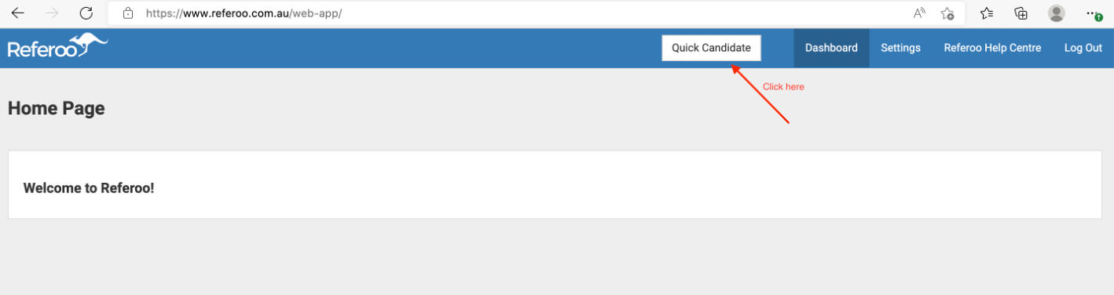

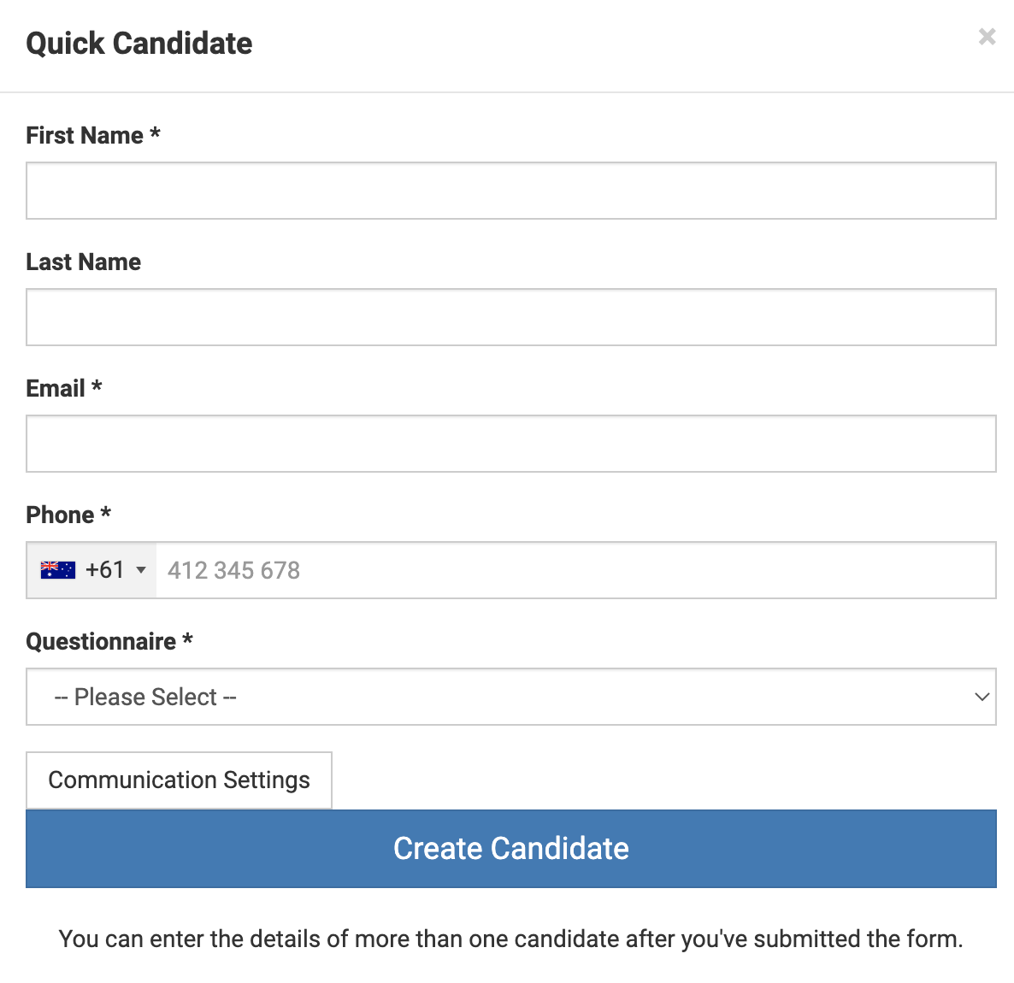
Select the relevant questionnaire
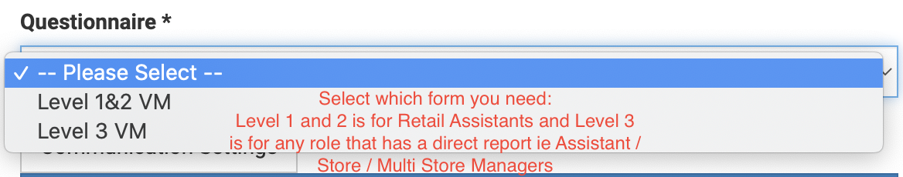

Leave communication settings as is
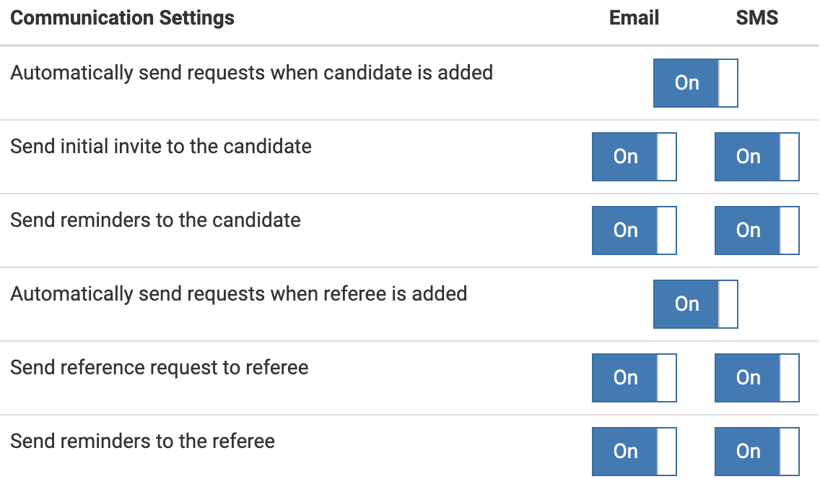
Insert the name and contact details for the candidate

